A1-2018-SQL-DBS301

DUE DATE: Nothing will be accepted after this date. It will get a zero

**Due BEFORE MIDNIGHT on the FRIDAY of WEEK 6 – no other extensions**

**PLAGIARISM**   
When you submit an assignment, you are saying that the submission is your own work or your groups own work and as such you wish to be given credit for the work.

Occasionally, it may be necessary to ask someone for a small amount of help. You are permitted to do so, provided you meet the following two conditions.

1 You acknowledge the help on the work you hand in, including explaining the work or portion of the work done or assisted by another person.

2 You understand the work that you hand in, so that you could explain the reasoning behind the parts of the work done for you or assisted by another.

Any other assistance by another person constitutes a violation called plagiarism and will be treated as such.

If two submissions exist, that are essentially the same, then both submissions cannot possibly make the claim that the work is "solely their own". This is a serious matter and is considered plagiarism. It is recorded in accordance with College policy and may result in a penalty such as expulsion from the College. Please do not put yourself in this position. Plagiarism is very easy to detect.

**Understanding what group works means**

This assignment can be done in groups. Ideal might be 2 to 4, but is not limited to that number.

It is suggested that you ALL do it individually and then meet to compare answers. Those not doing the work should be dropped from your group.

**VERY IMPORTANT:**

Being part of a group is the same as being a part of a team for these assignments. When you submitted your work as part of a group you are saying that:

you understood what was submitted and that you fully participated with ALL the group members.

It does not mean letting others do your work for you.

It does not mean watching the others do the work.

For your full participation, you get a mark equal to all the others in the group. If on the test, which is very much like the assignment, you cannot answer the questions, it strongly indicates that you didn’t participate and understand the assignment but depended on others for the mark you received. That is very much like submitting their work and claiming it is your work.

Which member account was the work submitted done on. _ **dbs301_182d67___**

**Anyone not in this list at submission time, cannot be added to the group later**

|  |  |  |  |
| --- | --- | --- | --- |
| Name | Student ID | Email address | Oracle ID |
| Jihee Byun | 121699169 | Jbyun2@myseneca.ca | dbs301_182d04 |
| HongBack Son | 133181164 | [Hbson1@myseneca.ca](mailto:Hbson1@myseneca.ca) | Dbs301_182d22 |
| Tomi O’Neil | 142123432 | [Tomio425@myseneca.ca](mailto:Tomio425@myseneca.ca) | Dbs301_182d34 |
|  |  |  |  |
|  |  |  |  |

________________________________________________________________________

The above list of names acknowledges you understand.

INSTRUCTION:

1 Please rerun the scripts CMC and demo. They have been updated.

2 Rename this WORD file A1-xxxxx where xxxxx is replaced with one of your email account name, not the whole email. If you are in a group pick one of them.

3 When finished email this back to me and CC everyone in your group as proof it was sent.

4 The following tables are used for this assignment. You have loaded the 2 scripts already.

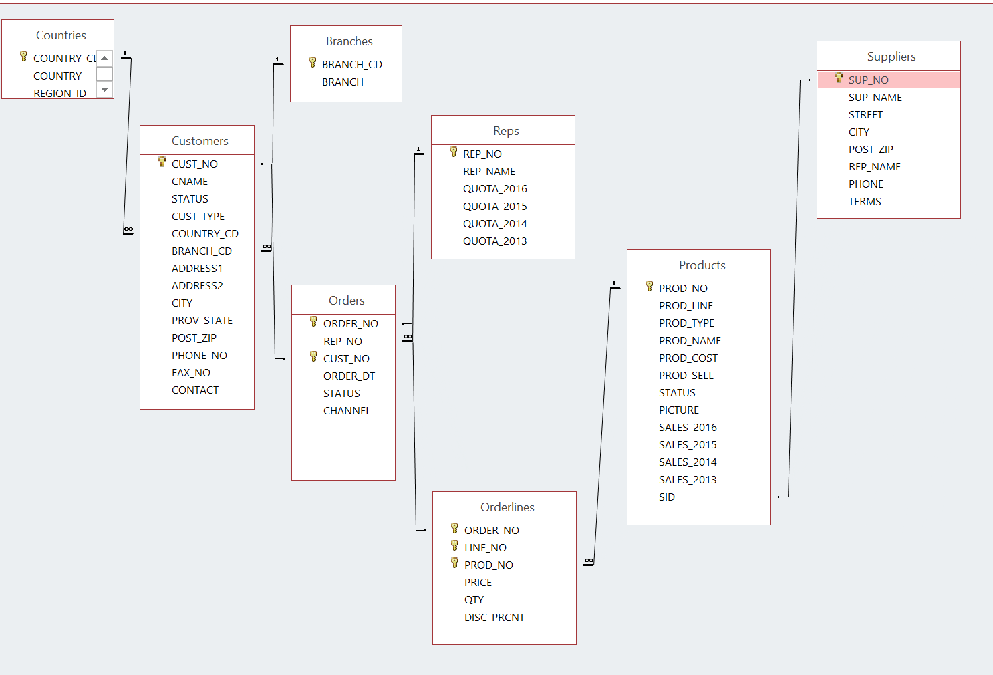

The above comes from the script CMC

NOTE:

If any output goes on for more than 100 lines, only cut and paste the first 100 or so. I don’t want to get this word document too big.

**ALL WORK MUST BE DONE ON SENECA’S ORACLE ACCOUNT**

**SQL that does not follow easily readable standard formats will not be marked.**

1 Display the customer number, customer name and country code for all the customers that are in the UK. The country code for United Kingdom is UK.

Please note that the user could have used UK, Uk, uk, uK. Your SQL must allow for various user inputs of the code. They are not entering the country name.

**SQL:** **select cust_no, cname, country_cd**

**from customers**

**where upper(substr(country_cd, 1, 2)) = upper('uk');**

**OUTPUT:**

**CUST_NO CNAME CO**

**---------- ------------------------------ --**

**1065 Trees to Seas Ltd UK**

**1089 Rock Steady 3 UK**

**1111 Wally Mart 1 UK**

**1112 Wally Mart 2 UK**

**1120 GO Outlet London UK**

**1121 GO Outlet Manchester UK**

**1127 Fresh Air Co 1 UK**

**1128 Fresh Air Co 2 UK**

**1129 Fresh Air Co 3 UK**

**1134 Breathe Free ltd UK**

**1025 Fresh Air Co 5 UK**

**CUST_NO CNAME CO**

**---------- ------------------------------ --**

**1026 GO Outlet London UK**

**12 rows selected.**

2. For any GO Outlets list the customer number, customer name and order number if they ordered any of these products -- 40303, 40301, 40306. Put result in customer number order.

**SQL:** **select c.cust_no,cname,o.order_no from customers c**

**join orders o on (o.cust_no = c.cust_no)**

**join orderlines ol on (ol.order_no = o.order_no)**

**join products p on (p.prod_no = ol.prod_no)**

**where p.prod_no in (40303,40301,40306) and c.cname like 'GO%' order by c.cust_no;**

**OUTPUT:** **Substitution cancelled**

**CUST_NO CNAME ORDER_NO**

**---------- ------------------------------ ----------**

**1009 GO Outlet Kista AB 137**

**1011 GO Outlet Singapore 200**

**1098 GO Outlet Madrid 27**

**1120 GO Outlet London 49**

**1121 GO Outlet Manchester 15**

**1122 GO Outlet New York 278**

**1122 GO Outlet New York 218**

**7 rows selected.**

3 Display all orders for United Kingdom.

The word entered is United Kingdom and not UK.

Show only cities that start with L.

Display the customer number, customer name, order number, product name, the total dollars for that line on the order.

Give that last column the name of 🡺 Total.

Put the output into customer number order from highest to lowest

and display only order numbers less than 1000

**SQL:** **select c.cust_no,c.cname,o.order_no,p.prod_no,c.city,ct.country_name, ol.price*ol.qty AS Total from customers c**

**join orders o on o.cust_no = c.cust_no**

**join orderlines ol on ol.order_no = o.order_no**

**join products p on p.prod_no = ol.prod_no**

**join countries ct on ct.country_id = c.country_cd**

**where upper(ct.country_name) = upper('United Kingdom') and c.city like 'L%' and o.order_no < 1000 order by c.cust_no desc;**

**OUTPUT:**

**CUST_NO CNAME ORDER_NO PROD_NO CITY COUNTRY_NAME TOTAL**

**---------- ------------------------------ ---------- ---------- -------------------- ---------------------------------------- ----------**

**1120 GO Outlet London 61 60500 London United Kingdom 165**

**1120 GO Outlet London 49 40300 London United Kingdom 14**

**1120 GO Outlet London 61 50202 London United Kingdom 384**

**1120 GO Outlet London 61 40201 London United Kingdom 1677**

**1120 GO Outlet London 61 40403 London United Kingdom 1533**

**1120 GO Outlet London 61 40100 London United Kingdom 5610**

**1120 GO Outlet London 107 60302 London United Kingdom 1536**

**1120 GO Outlet London 107 60501 London United Kingdom 24880**

**1120 GO Outlet London 107 60202 London United Kingdom 396**

**1120 GO Outlet London 107 50203 London United Kingdom 256**

**1120 GO Outlet London 107 40200 London United Kingdom 228**

**CUST_NO CNAME ORDER_NO PROD_NO CITY COUNTRY_NAME TOTAL**

**---------- ------------------------------ ---------- ---------- -------------------- ---------------------------------------- ----------**

**1120 GO Outlet London 107 40401 London United Kingdom 1170**

**1120 GO Outlet London 61 60501 London United Kingdom 8370**

**1120 GO Outlet London 49 40301 London United Kingdom 262**

**1120 GO Outlet London 49 40402 London United Kingdom 1512**

**1120 GO Outlet London 49 50201 London United Kingdom 320**

**1120 GO Outlet London 49 60501 London United Kingdom 3780**

**1120 GO Outlet London 49 60300 London United Kingdom 558**

**1120 GO Outlet London 29 40201 London United Kingdom 2064**

**1120 GO Outlet London 29 40402 London United Kingdom 1512**

**1120 GO Outlet London 29 50202 London United Kingdom 640**

**1120 GO Outlet London 29 60302 London United Kingdom 1806**

**CUST_NO CNAME ORDER_NO PROD_NO CITY COUNTRY_NAME TOTAL**

**---------- ------------------------------ ---------- ---------- -------------------- ---------------------------------------- ----------**

**1120 GO Outlet London 29 60100 London United Kingdom 558**

**1065 Trees to Seas Ltd 170 40201 London United Kingdom 123**

**1065 Trees to Seas Ltd 170 50101 London United Kingdom 2800**

**1065 Trees to Seas Ltd 170 60401 London United Kingdom 1881**

**1065 Trees to Seas Ltd 170 60202 London United Kingdom 924**

**1065 Trees to Seas Ltd 122 60100 London United Kingdom 530**

**1065 Trees to Seas Ltd 122 40300 London United Kingdom 84**

**1065 Trees to Seas Ltd 122 50102 London United Kingdom 1984**

**1065 Trees to Seas Ltd 122 60301 London United Kingdom 1027**

**1065 Trees to Seas Ltd 122 60402 London United Kingdom 495**

**1065 Trees to Seas Ltd 122 40401 London United Kingdom 936**

**33 rows selected.**

4 Find the total dollar value for all orders from London. Each row will show customer name, order number and total dollars for the order. Sort by order number

**SQL:** **select cname,o.order_no,ol.price*ol.qty AS total from customers c**

**join orders o on o.cust_no = c.cust_no**

**join orderlines ol on ol.order_no = o.order_no**

**where upper(c.city) = upper('london') order by order_no;**

**OUTPUT:**

CNAME ORDER_NO TOTAL

------------------------------ ---------- ----------

GO Outlet London 29 2064

GO Outlet London 29 1512

GO Outlet London 29 640

GO Outlet London 29 1806

GO Outlet London 29 558

GO Outlet London 49 3780

GO Outlet London 49 320

GO Outlet London 49 1512

GO Outlet London 49 262

GO Outlet London 49 558

GO Outlet London 49 14

CNAME ORDER_NO TOTAL

------------------------------ ---------- ----------

GO Outlet London 61 5610

GO Outlet London 61 1533

GO Outlet London 61 1677

GO Outlet London 61 384

GO Outlet London 61 165

GO Outlet London 61 8370

GO Outlet London 107 228

GO Outlet London 107 1170

GO Outlet London 107 256

GO Outlet London 107 396

GO Outlet London 107 24880

CNAME ORDER_NO TOTAL

------------------------------ ---------- ----------

GO Outlet London 107 1536

Trees to Seas Ltd 122 530

Trees to Seas Ltd 122 84

Trees to Seas Ltd 122 1027

Trees to Seas Ltd 122 1984

Trees to Seas Ltd 122 936

Trees to Seas Ltd 122 495

Trees to Seas Ltd 170 2800

Trees to Seas Ltd 170 1881

Trees to Seas Ltd 170 924

Trees to Seas Ltd 170 123

33 rows selected.

5 For all orders in the orders table supply order date and count of the number of orders on that date. Only include those from 2015 and have more then 1 order on that date.

**SQL:** **select order_dt,count(order_no)from orders**

**where order_dt >= '01-jan-2015' group by order_dt having count(order_dt) >1;**

**OUTPUT:** **ORDER_DT COUNT(ORDER_NO)**

**----------- ---------------**

**09-Nov-2014 2**

**02-Apr-2015 3**

**21-Oct-2013 2**

**02-Dec-2014 3**

**28-Jan-2015 2**

**28-Feb-2015 2**

**29-Mar-2015 2**

**07-Feb-2013 2**

**17-Feb-2013 2**

**02-May-2013 2**

**19-Jul-2013 2**

**ORDER_DT COUNT(ORDER_NO)**

**----------- ---------------**

**24-Oct-2013 2**

**13-Feb-2014 2**

**03-Jul-2014 2**

**29-Nov-2014 2**

**23-Feb-2015 2**

**27-Feb-2013 2**

**12-May-2014 2**

**08-Jul-2014 3**

**26-Nov-2014 2**

**07-Apr-2013 2**

**16-Dec-2013 2**

**ORDER_DT COUNT(ORDER_NO)**

**----------- ---------------**

**20-Jul-2014 2**

**05-Aug-2014 2**

**28-Sep-2014 2**

**09-Mar-2015 2**

**11-Mar-2014 2**

**22-Mar-2014 3**

**20-Mar-2015 2**

**21-Apr-2014 2**

**10-Oct-2014 3**

**26-Mar-2015 2**

**12-Mar-2014 2**

**ORDER_DT COUNT(ORDER_NO)**

**----------- ---------------**

**12-Oct-2014 2**

**23-Oct-2014 2**

**20-Nov-2014 2**

**10-Feb-2015 3**

**12-Feb-2015 2**

**20-Aug-2013 2**

**39 rows selected.**

6 The Sales Manager would like to see all orders in 2014 from United Kingdom and Canada.

Show the customer number, customer name and country name

**SQL:** **select cust_no, cname,**

**substr(country_name, 1, 18) "COUNTRY_NAME"**

**from customers**

**join countries on countries.country_id = substr(customers.country_cd, 1, 2)**

**join orders using (cust_no)**

**where country_name in ('United Kingdom', 'Canada')**

**and to_date(order_dt, 'DD-MON-YY') between to_date('01-JAN-14', 'DD-MON-YY') and to_date('31-DEC-14', 'DD-MON-YY');**

**OUTPUT:**

**CUST_NO CNAME COUNTRY_NAME**

**---------- ------------------------------ ------------------**

**1065 Trees to Seas Ltd United Kingdom**

**1065 Trees to Seas Ltd United Kingdom**

**1067 Andes Camping Supplies 1 Canada**

**1067 Andes Camping Supplies 1 Canada**

**1069 Andes Camping Supplies 3 Canada**

**1069 Andes Camping Supplies 3 Canada**

**1092 Clear Valley Waters 2 Canada**

**1092 Clear Valley Waters 2 Canada**

**1111 Wally Mart 1 United Kingdom**

**1127 Fresh Air Co 1 United Kingdom**

**1128 Fresh Air Co 2 United Kingdom**

**CUST_NO CNAME COUNTRY_NAME**

**---------- ------------------------------ ------------------**

**1128 Fresh Air Co 2 United Kingdom**

**1128 Fresh Air Co 2 United Kingdom**

**1129 Fresh Air Co 3 United Kingdom**

**1129 Fresh Air Co 3 United Kingdom**

**1132 Excellence en Montagne Canada**

**1025 Fresh Air Co 5 United Kingdom**

**1033 Supras Camping Suplies 3 Canada**

**1042 Vacation Central 4 Canada**

**1042 Vacation Central 4 Canada**

**1048 Supras Camping Supplies 5 Canada**

**1048 Supras Camping Supplies 5 Canada**

**CUST_NO CNAME COUNTRY_NAME**

**---------- ------------------------------ ------------------**

**1048 Supras Camping Supplies 5 Canada**

**23 rows selected.**

7 The President wants to know out of the 150 customers on file, how many customers have not placed an order?

**SQL:** **select count(cust_no) "Count of unordered customers"**

**from customers**

**where cust_no not in (select cust_no**

**from orders);**

**OUTPUT:**  **Count of unordered customers**

**----------------------------**

**47**

8 Show what customers (number and name) along with the country name for all customers that are in the same countries as the Supra customers. Limit the list to any customer that starts with the letters A or B.

**SQL:** **select cust_no, cname,**

**substr(country_name, 1, 29) "COUNTRY_NAME"**

**from customers**

**join countries on countries.country_id = substr(customers.country_cd, 1, 2)**

**where cname like 'A%' or cname like 'B%'**

**and country_name in (select country_name**

**from countries**

**join customers on countries.country_id = substr(customers.country_cd, 1, 2)**

**where cname like 'Supra%');**

CUST_NO CNAME COUNTRY_NAME

---------- ------------------------------ -----------------------------

1067 Andes Camping Supplies 1 Canada

1068 Andes Camping Supplies 2 Canada

1069 Andes Camping Supplies 3 Canada

1070 Andes Camping Supplies 4 Canada

1072 Advanced Climbing Ltd United States of America

1075 Act'N'Up Fitness 1 United States of America

1076 Act'N'Up Fitness 2 United States of America

1077 Act'N'Up Fitness 3 United States of America

1078 Act'N'Up Fitness 4 United States of America

1086 All season camping goods United States of America

1133 Back woods up front Ltd. Canada

CUST_NO CNAME COUNTRY_NAME

---------- ------------------------------ -----------------------------

1006 Bergsteiger G.m.b.H. Germany

1010 Andes Camping Supplies 6 Canada

1012 Act'N'Up Fitness 5 United States of America

14 rows selected.